**Present Experiment**

In this experiment, we try to render a defocused image accurately because it will test whether our models of the eye are accurate enough, and it will be useful to people in computer graphics who are trying to accurately depict scenes containing objects at different distances where some of them will inevitably be out of focus.

They did two experiments: one experiment is for comparing VA and another experiment is for subjective comparison. They findings indicated that the eye's high- order aberrations (HOAs) don't substantially change the VA for Landolt C stimuli. However, the images blurred with HOAs are qualitatively different from those blurred without HOAs, and in almost all cases the observer judged those blurred with HOAs more closely resembling the actual optically blurred stimuli. This indicates that HOAs might well be significant in cases where the rendered blur attempts to make a stimulus as realistic as possible.

However, that simple VA comparison will not tell us how accurate a stimulus is with rendered blur. Because Abigail has measured just two eyes in the experiment, it is necessary to test a larger number of observers to determine how robust these effects are. Also, several different HOAs may be checked to see whether there is a particular collection of HOAs that could boost the realism of rendered blur for the majority of the populace. In this experiment, blur is rendered into visual stimuli in different types, and then we will measure the visual acuity.

Aim

This experiment aims to be investigating the difference between optical and render blur through studying the effect on VA to use this to get a sense of how similar the rendered blur is to true optical (if VA is different, the images must also be different, although the converse is not true even if VA is the same, the images could still look different), and specifically which method produces results most similar to pure optical blur.

The previous studies used unrealistic PSF and broadband stimuli so that LCA is present in optical defocus but not rendered, which caused weaknesses for these studies.

In this study, we will avoid those weaknesses and we will do the following:

• We will measure observer’s actual HOAs so that in theory the PSF should be perfectly accurate if rendered blur = optical for that accurate PSF, so we will measure spherical aberration, astigmatism and defocus.

• We will use one primary of the CRT (green) so that there should be minimal LCA in the optical case.

• We will make sure the stimulus is at the observer’s far point so that accommodation cannot help them reduce optical blur and we may run a follow-up experiment with cycloplegia to confirm this.

• We will use an artificial pupil so that pupil size is controlled.

**Design**

This experiment will explore two independent variables. The first is the type of blur: the first is a true optical blur by adding in a lens of a given power; the second is rendered blur with defocus only; the third is rendered blur with defocus plus an amount of spherical aberration; the fourth is rendered blur with defocus plus “example” sets of higher-order aberrations (HOAs); and the final is rendered blur with defocus plus all own HOAs which I got by measured my own wavefront aberration via Shack‐Hartmann (SH) wavefront sensor. The second is the type of pupil, which is either an artificial pupil of 5 mm or the natural pupil of the observer. VA is the dependent variable in the experiment and will be measured by changing the stimulus size to find the performance threshold in the task in a step-staircase procedure. The VA computes as,

VAlogMAR = log10(gapsize) ……………………………………(4)

where VAlogMAR is the VA defined as the logarithm of the lowest resolution angle (logMAR), and where the gaps are the angular size of the smallest dimension to find where gapsize refer to Landlot C gap and the distance in Landolt C is in minutes of arc (arcmin).

**Task**

Will be measured the observer’s pupil size prior to the experiment. Participants will view an image of a Landolt C and will be asked to report which of four orientations they see. We will reduce the size of the C until participants can no longer perceive the size. This will be the measurement of VA as shown in Figure 1.14.

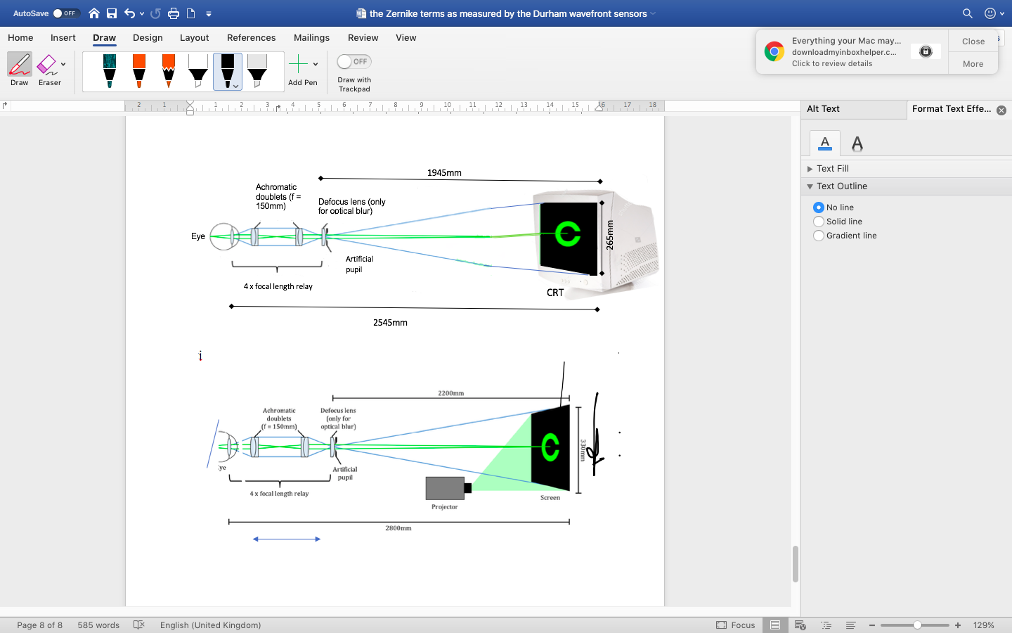

Figure 1.14: Diagram shows the stimuli onto a screen at 2545mm from the observer. The observer sees this screen through a relay lens system which composed of 2 achromatic doublets with focal lengths of 150mm each. This comes in a plane conjugate to the observer's pupil at 1945mm from the screen. In this plane, either a defocus lens or an artificial pupil, or both, might be set and exchanged in and out amid the course of the experiments using a ThorLabs double position slider.